Assignment – 3
Course Title : Introduction to Database Course Code : IT244

Q. 1 Normalize the following schema, with given constraints, to BCNF. (2 Point)
books(accessionn, isbn, title, author, publisher)
users(userid, name, deptid, deptname)

accessionno isbn
isbn title
isbn publisher
isbn author
userid name
userid deptid
deptid deptname

Q. 2 Consider the relational database given below, where the primary keys are underlined.
Give an expression in Tuple Relational Calculus and Domain Relational Calculus
for each of the following queries: (0.5+0.5 = 1 Point)
a. Find all employees who work directly for “STC”
b. Find all cities of residence of all employees who work directly for “STC”
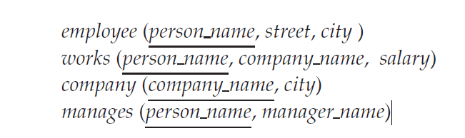

Q. 3 Consider the following database: (0.5+0.5+1= 2 Points)
person (driver_id, name, address)
car (license, model, year)
accident (report_number, date, location)
owns (driver_id, license)
participated (report_number, license, driver_id, damage_amount)
- Write SQL DDL corresponding to the following schema. Make any reasonable assumptions about data types, and be sure to declare primary and foreign keys.
- Find the number of accidents in which the cars belonging to “John Smith” were involved.
- Update the damage amount for the car with license number “AABB2000” in the accident with report number “AR2197” to $3000.

